Night WebQuest
by Elie Wiesel

Introduction:
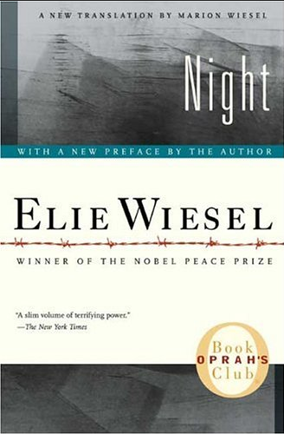
You will soon begin reading the memoir Night by Elie Wiesel. In preparation, it is extremely important that you gain the necessary background information in order to understand certain situations and events. This book is very disturbing as Mr. Wiesel shares his experiences in a Nazi Concentration Camp during World War II. Throughout the book, you will read about his horrific journey through evil and horror as a young European Jew.

“The opposite of love is not hate, it's indifference. The opposite of art is not ugliness, it's indifference. The opposite of faith is not heresy, it's indifference. And the opposite of life is not death, it's indifference.”
― Elie Wiesel

Task:
Explore Web sites on various topics related to the Jewish Holocaust. You will be given a selection of web sites, via QR Codes, related to these issues from which to choose. The webquest will provide you with a heightened understanding of the Holocaust, background information related to the novel and author, and context for the setting of the novel.

QR Codes:
Make sure your device has a QR Code reader downloaded. I recommend using Qrafter.

Background for Night and the Holocaust

Section I: The Author
http://www.eliewieselfoundation.org/eliewiesel.aspx  http://www.ushmm.org/wlc/en/media_nm.php?ModuleId=10005143&MediaId=3372 | 1. Where was Elie born? In what year?  2. What happened to him at the age of fifteen?  3. Elie received an appointment from President Jimmy Carter. For what was that?  4. Where does Elie teach?  5. What great honor did he receive in 1986?
Section II: The Holocaust
http://history1900s.about.com/od/holocaust/a/holocaustfacts.htm | 6. What does the term “holocaust” mean?  7. When did the Holocaust begin?  8. How many Jews were murdered during the Holocaust?  9. What laws excluded the Jews from public life in Germany?  10. What were the Jews forced to wear to distinguish themselves?
Section III: The Final Solution
http://www.ushmm.org/wlc/en/article.php?ModuleId=10005151 | 11. Nazis coined the term "The Final Solution." To what does this term refer? Why did they use this language?  12. What were some of the stages implemented as part of "The Final Solution?"  13. What was the intended purpose of these state-sponsored programs?
Section IV: The Ghettos
http://www.ushmm.org/wlc/en/article.php?ModuleId=10005059 | 14. How were ghettos used just before and during WWII?  15. Where were the first ghettos set up?  16. How many ghettos were established?  17. Why did the Nazis initially set up ghettos?  18. What happened with the ghettos after the implementation of the "Final Solution" in 1941?
Section V: Auschwitz
http://www.ushmm.org/outreach/en/article.php?ModuleId=10007718 | 19. Where was (and still is) Auschwitz located?  20. What was Auschwitz?  21. How many people were killed there?  22. What were some of the things that first happened to people arrived at the camps?  23. What was everyday life like in terms of clothing, food, and the bathrooms?
Section VI: Gassing Operations
http://www.ushmm.org/wlc/en/article.php?ModuleId=10005220.com | 24. Who did the Nazis begin using poisonous gas on in 1939?  25. Why did the Nazis begin using mobile killing units instead of shooting squads?  26. What did the Nazi SS guards pretend the gas chambers were?  27. At the height of its operation, how many people were gassed daily at Auschwitz?
Section VII: Doctor Mengele
http://history1900s.about.com/od/auschwitz/a/mengeletwins.htm  http://isurvived.org/drMengele.html | 28. How Dr. Mengele believe the secrets of heredity would help the Nazi ideal of the future?  29. On whom did Dr. Mengele primarily perform experiments?  30. While Dr. Mengele's experiments were unimaginably cruel, some scientific discovery came out of them that we still use today (pressurized airplanes, dental procedures, etc). Some have argued that Dr. Mengele should be given credit for these discoveries. Others argue that he should receive no credit since the nature of his experiments was so brutal. What do you think and why do you feel this way?
Section VIII: The End of the War
http://www.ushmm.org/wlc/en/media_nm.php?MediaId=7827 | 31. When did Soviet Forces start liberating territory from German domination?  32. When did the liberation of Western Europe begin?  33. Why did the Germans force the evacuation of many of the concentration camps?  34. When and why did WWII end?  35. What had happened to the Jewish population in Europe?

